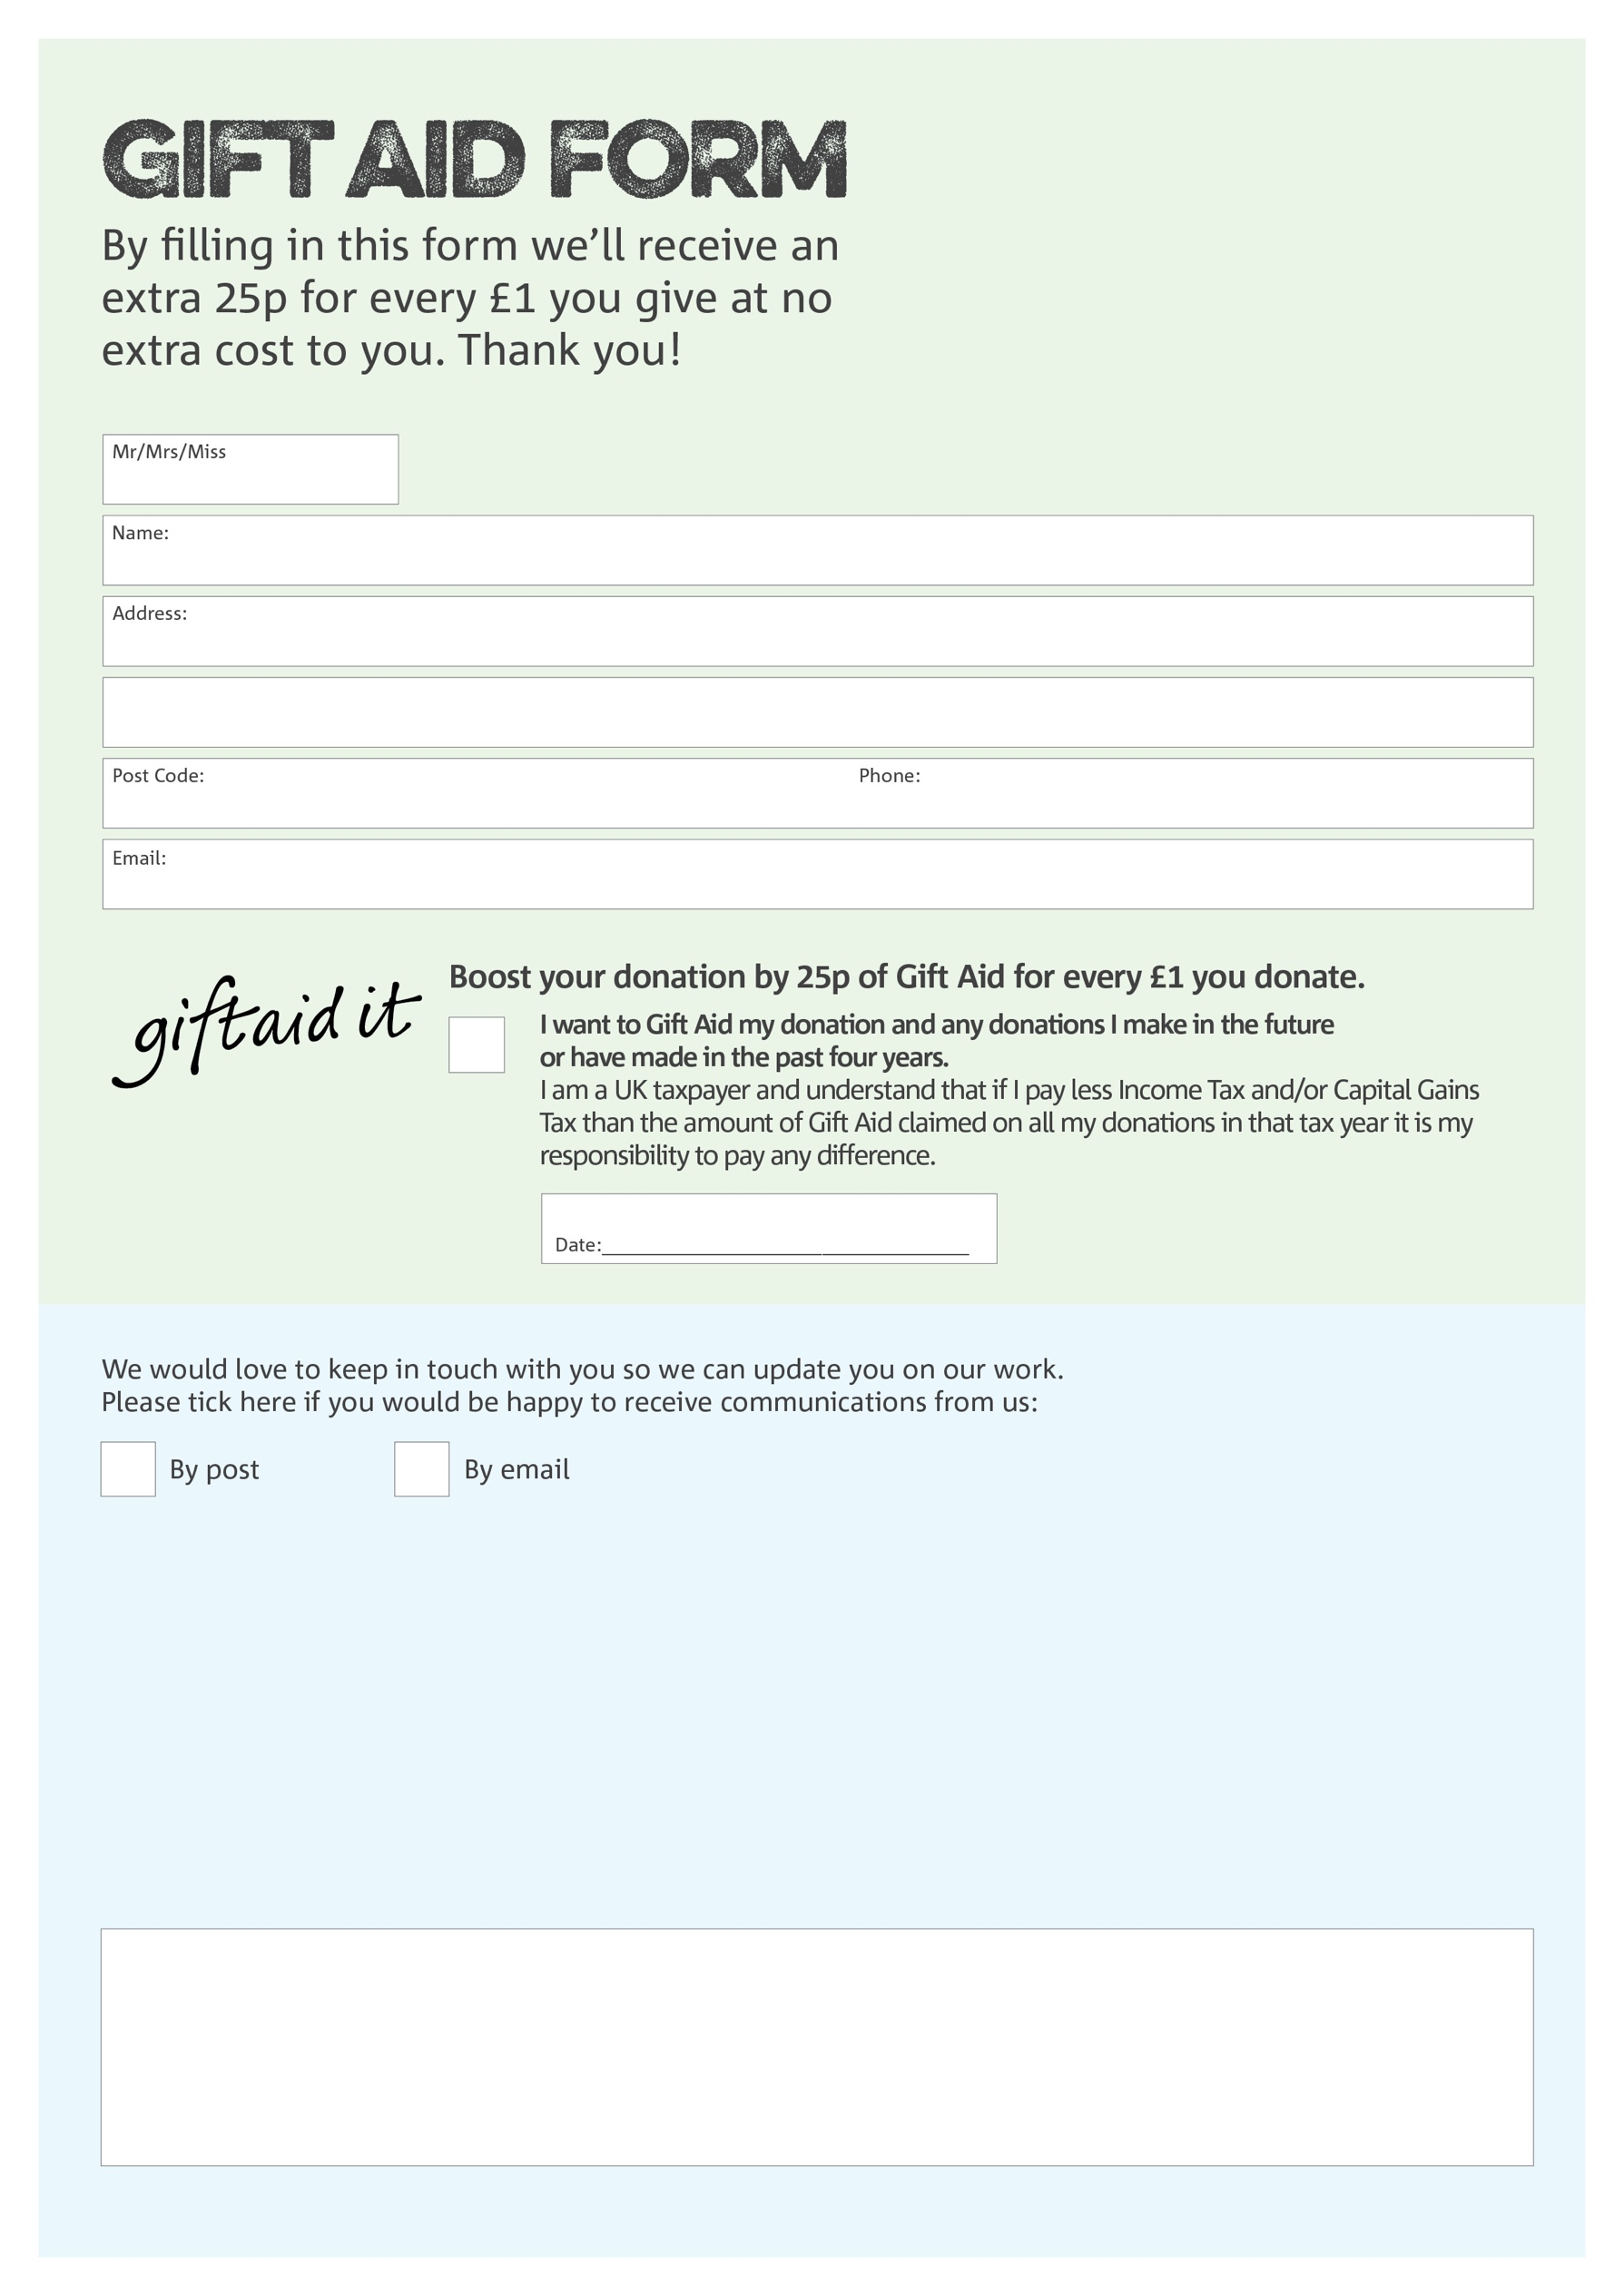

**Data protection**

Tottenham Foodbank is committed to protecting your privacy and will process your personal data in accordance with the Data Protection Act 1998. Tottenham Foodbank collects information to keep in touch with you and supply you with information relating to our work. Tottenham Foodbank will never sell or pass your details to anyone who isn’t directly working on our behalf.

You can change your preferences any time by contacting us on 020 8493 0050 or emailing us at [info@tottenham.foodbank.org.uk](mailto:info@tottenham.foodbank.org.uk)

We would love to know why you have chosen to donate to Tottenham Foodbank. If you would like to share your motivation let us know below:

Charity Number 1040704. Registered in 1994